Name: James Farrow

Course: CS 340 Client/Server Development

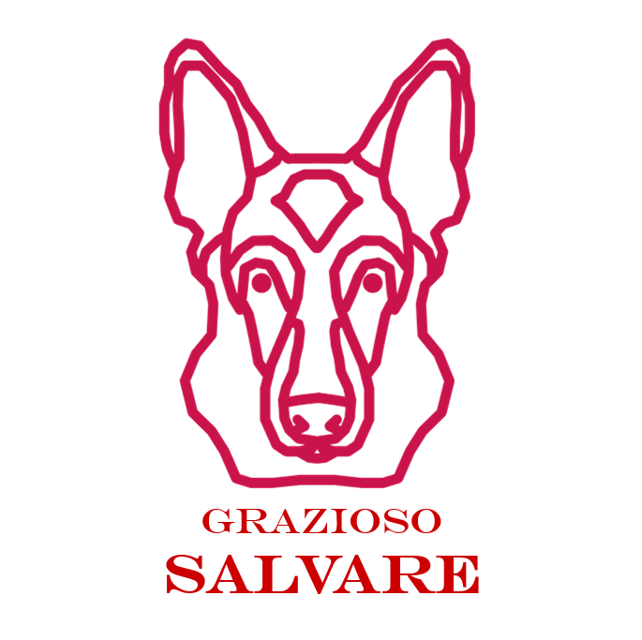

This dashboard within my program focuses on combining the components from Project One, Module Six and Project Two. The intention for this program is to connect the MongoDB database. The files that are used within this project are [AnimalShelter.py](http://animalshelter.py), AnimalShelter.ipynb, and ProjectTwoDashboard.

Within this program, the pie chart is able to display the breeds and showcase the results as well. One of the benefits of my program is it also displays the location along with the name. All animal data information is showcased within the DataTable. Filters are also able to be applied. The program allows for live updating and filtering. The program contains the title which is Grazioso Salvare.

How to use this program?

* Upload all files onto a working directory
* Open ProjectTwoDashboard.ipynb
* Utilize dropdown and table allowing you to check animal data

